- SPEEDWAY & SIDECAR RACING
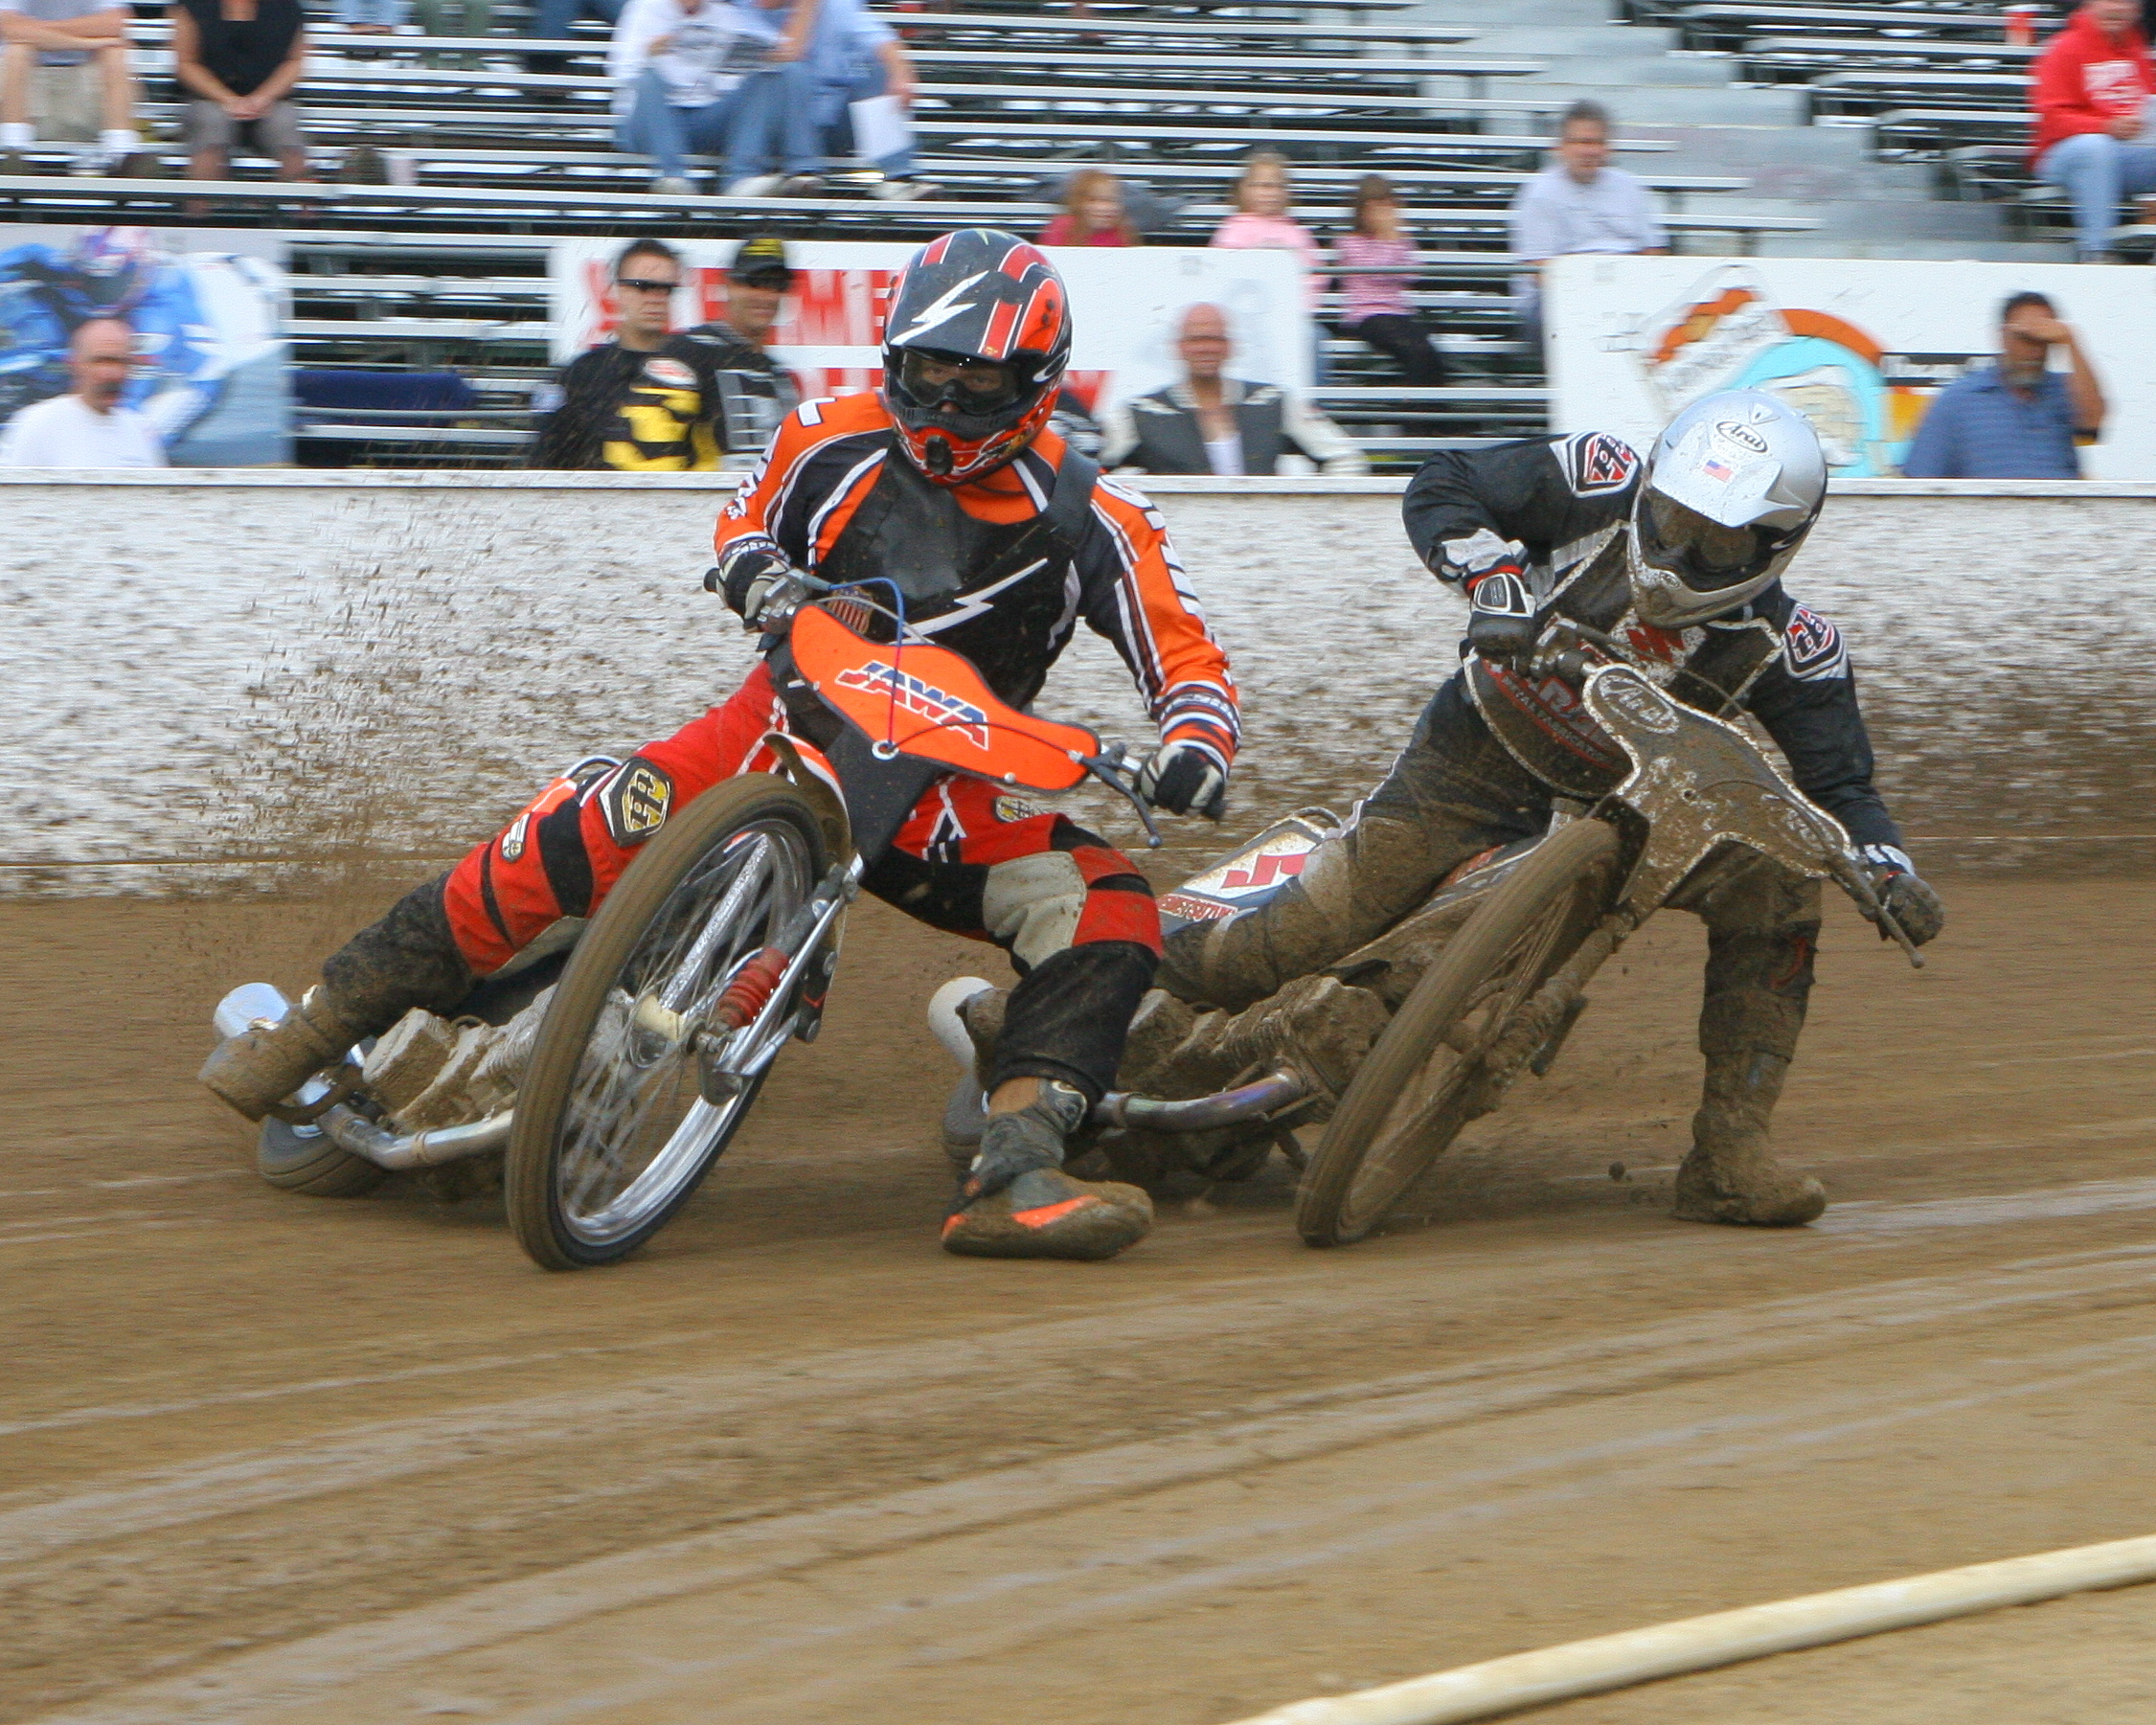
@ Wheel 2 Wheel Raceway, San Bernardino County Fairgrounds, Victorville (Exit I-15 @ Roy Rogers) Free Parking! Free Programs!

2006 Fall Schedule;
23 September (6pm) Sidecar National Championship & Speedway bike
Track Championships
21 October (6pm) West Coast Speedway League Victorville Vikings Vs Los Angeles Aces plus Sidecars, Juniors
4 November (3pm) West Coast Speedway League Victorville Vikings
Vs Orange County Eagles plus Sidecars, Juniors
18 November (3pm) West Coast Speedway League Victorville Vikings
Vs Sacramento Silver Machine plus Sidecars, Juniors

$10 Admission! Kids $5! Great family night out!
www.myspace.com/victorvillespeedway Tel: 310 309 9418
SPONSOR PACKAGES AVAILABLE CALL FOR DETAILS!

